Jenkins in vagrant
How to run vagrant in Jenkins:
Open the git bash,
Here create the one mkdir and configer the vim vagrantfile in this file enter the we use whatevery tool give that version and select the memory and ip address and do some settings then save the vagrantfile, [save command first click on the keyboard in left side top first button [Esc]then :wq! Then click on the enter button
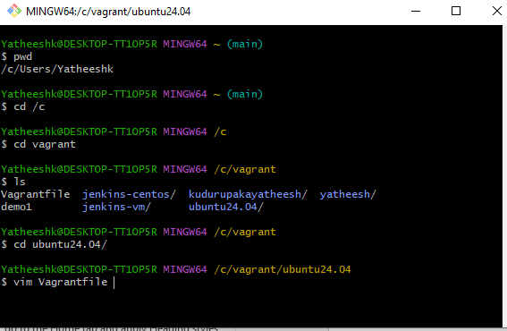

enter the version: bento/ubuntu-24.04
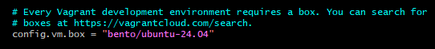
Enter the private network
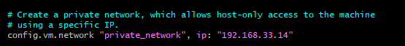
Select the memory,change the memory
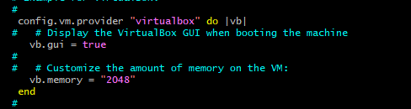
Then save the vagarntfile
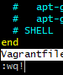

Do this command navigate to the Vagrant, vagrant up [wait few mints loading]
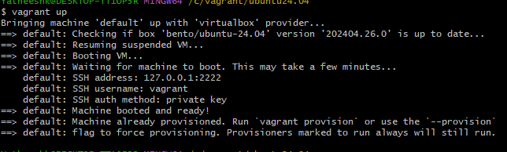
Next vagrant ssh [wait some time loading the vagrant ssh
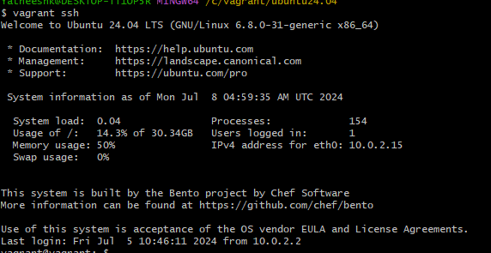
Navigate to the new tab, enter the your private ip address and enter the your defalt Jenkins port number then click on the enter button.
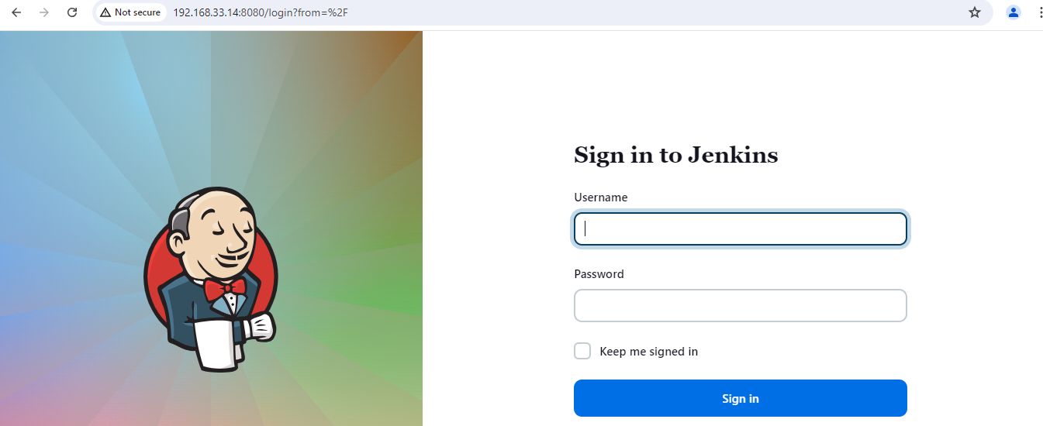
Create the Jenkins account enter, set the user name and password,
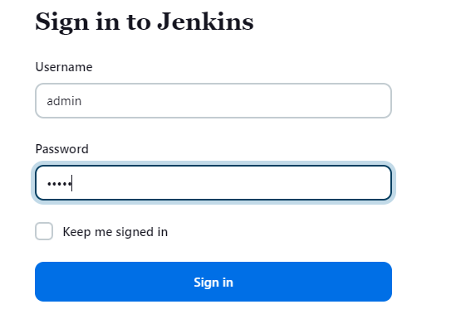
Display the like this down page navigate the manage Jenkins and here we install the plugins, plugins means like maven, sonarqub, github
